

TITLE OF THE PROJECT-

BLOOD DONATION WEBSITE

|  |  |  |  |
| --- | --- | --- | --- |
| S.NO | REG. NO | NAME | ROLL.NO |
| 1 | 11903893 | YERUVA SNEHITH REDDY | 3 |
| 2 | 11904655 | JAYANT SINGH BADAURIA | 2 |
| 3 | 11905568 | NIKHIL GAUTAM | 1 |

SUBMITTING TO-

DR.SUKHVIR KAUR

BLOOD DONATION PROJECT

INTRODUCTION-

This project is designed for successful completion of a project on blood bank management system.

The basic building aim is to provide blood donation service to the city recently. Blood Bank Management System (BBMS) is a Web-based application that is designed to store, process, retrieve and analyze information concerned with the administrative and inventory management within a blood bank.

This project aims at maintaining all the information pertaining to blood donors, different blood groups available in each blood bank and help them manage in a better way.

Project Aim is to provide transparency in this field, make the process of obtaining blood from a blood bank hassle-free and corruption-free and make the system of blood bank management effective.

Blood Bank donation system can collect blood from many donators in short from various sources and distribute that blood to needy people who require blood.

This website has many facilities such as online transfer of blood from one blood bank to another. This project can manage the list of donors who are eligible for blood donation on articular date with contact number.

The main aim of the project is to effectively manage the blood banking system. This project enables the users to access nearest blood bank . it also checks the availability of the required blood group , provides necessary information about the volunteer blood donors who have registered by going through the website.



Blood donation is required during an organ transplant, accidents, cancer treatment etc. For blood donation, one needs to check for a donation camp or needs to visit blood bank. The Manual Blood donation system has many disadvantages which includes, it is too time consuming, often leads to error prone results, consumes lot of manpower, lacks donor information, retrieval of data takes a lot of time, percentage of accuracy is less. In the time of emergency, it becomes difficult to approach the right donor. Rare blood groups are not available all the time at all blood banks and recipients find difficulties to track the right blood donor. To overcome this problem, Nevon Projects has proposed a system. There are many blood donation management systems, but these systems only maintain the information of blood banks and donors. But Nevon projects has proposed a system which not only maintains the information of blood banks, but also maintains information of blood camps which makes blood transfusion process easier. This online blood donation management system maintains the list of blood donors and also helps the recipients to track and search the right donor easily. It has two modules namely Admin and User. Admins can add hospitals having blood banks and can also add various blood donation camps. He/she can also view the list of donors of a particular area with proper Blood cross match. He/she can also check for blood requests and in case of emergency he/she can send notifications to blood donors as per the requirements. Users can register and make a request. Users can also register as a donor. Donors can check for Blood camps and hospitals for blood donation and will be getting notifications in case of emergency. They can either accept or ignore it. This project aims at maintaining all information regarding blood donors, different blood groups available in blood banks as wells as blood camps and help them manage in a better way.

OBJECTIVES-

• An easy way to search the nearest blood banks to the accident site with the help of

GPS.

• An effective way to find out the availability of the required blood groups in the

blood banks.

• A proficient way to search the volunteer blood donors.

• Providing tips regarding the necessary measures that are to be taken before the

blood donation.

FLOW CHART-

The main aim of this study is to offers such a cross platform web interface which will let anybody to access the detail contact of potential blood donors around the required location. An algorithm has been developed to identify the potential blood donors. A website has also been created using this algorithm in the backend using HTML5, PHP and JAVA programming languages. XAMMP software was used in hosting local server. Several automated blood management system are available like the Facebook blood donation, but none of them offer any efficient algorithm considering the variables like frequency of blood donation, last date of donation, gender and age factor. To find the eligible donors we have considered all factors simultaneously, which makes the study unique. Practically this search engine will be helpful for the automated blood donation organizations and other blood bank for identifying the potential blood donors from their large database.

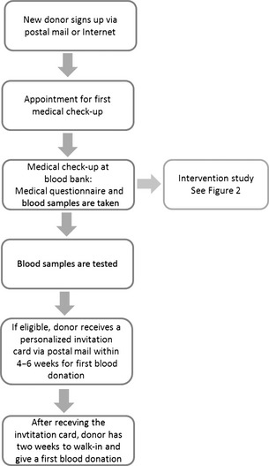

Figure shows the activity diagram for the system is briefly described in the system. The various activities that are invloved in the system are Register, Login,finding the nearest available donor.

After the request activites are performed, the admin will check for the available resources from the details requested by the requestor.

After checking and verifying the details the blood donation is confirmed.issued.

Finally the blood donation is confirmed.

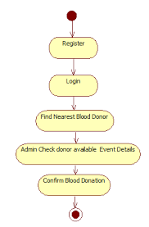

DATA FLOW DIAGRAM-

This is the DFD of blood bank management system , where we have elaborated the high level processof blood bank . It’s a basic overview of the whole blood bank management system or being analysed . Its designed th be an ata a gleance view of donor , order and patient showing the simple as a single high level process , with its relationship to external entities of blood , blood group and sells . It should be easily understood by a wide audience , including blood , sells and donor in DFD of blood bank management system , we have described the high level flow of the blood bank system.

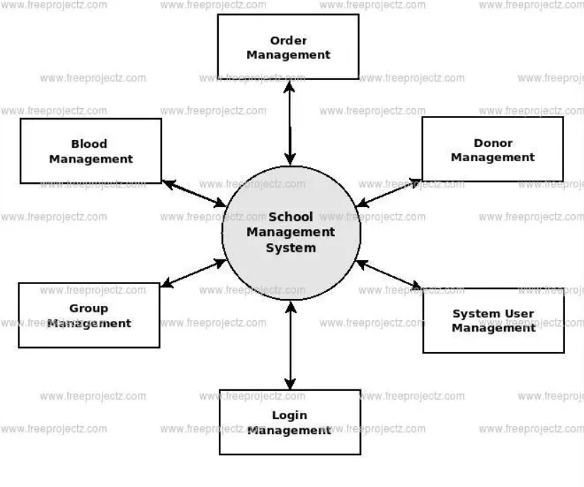

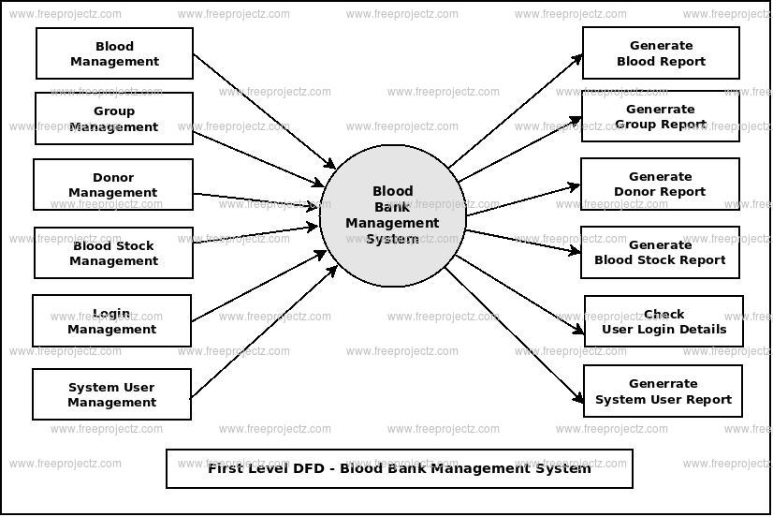

DESCRIPTION OF PROJECT-

DESCRIPTION-

In the above program we used a command called grid container . It is used when we have to display a property to grid. The grid-template-columns property defines the number of columns in your grid layout, and it can define the width of each column.

The value is a space-separated-list, where each value defines the length of the respective column.

If you want your grid layout to contain 4 columns, specify the width of the 4 columns, or "auto" if all columns should have the same width.

The grid-template-columns property can also be used to specify the size (width) of the columns.

In the blood donation website program the number of grids are created. Blood donation is required during an organ transplant, accidents, cancer treatment etc. For blood donation, one needs to check for a donation camp or needs to visit blood bank. The Manual Blood donation system has many disadvantages which includes, it is too time consuming, often leads to error prone results, consumes lot of manpower, lacks donor information, retrieval of data takes a lot of time, percentage of accuracy is less. In the time of emergency, it becomes difficult to approach the right donor. Rare blood groups are not available all the time at all blood banks and recipients find difficulties to track the right blood donor. To overcome this problem, Nevon Projects has proposed a system. There are many blood donation management systems, but these systems only maintain the information of blood banks and donors. But Nevon projects has proposed a system which not only maintains the information of blood banks, but also maintains information of blood camps which makes blood transfusion process easier. This online blood donation management system maintains the list of blood donors and also helps the recipients to track and search the right donor easily. It has two modules namely Admin and User. Admins can add hospitals having blood banks and can also add various blood donation camps. He/she can also view the list of donors of a particular area with proper Blood cross match. He/she can also check for blood requests and in case of emergency he/she can send notifications to blood donors as per the requirements. Users can register and make a request. Users can also register as a donor. Donors can check for Blood camps and hospitals for blood donation and will be getting notifications in case of emergency. They can either accept or ignore it. This project aims at maintaining all information regarding blood donors, different blood groups available in blood banks as wells as blood camps and help them manage in a better way.

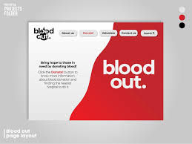

SCREENSHOT OF THE WEBSITE-

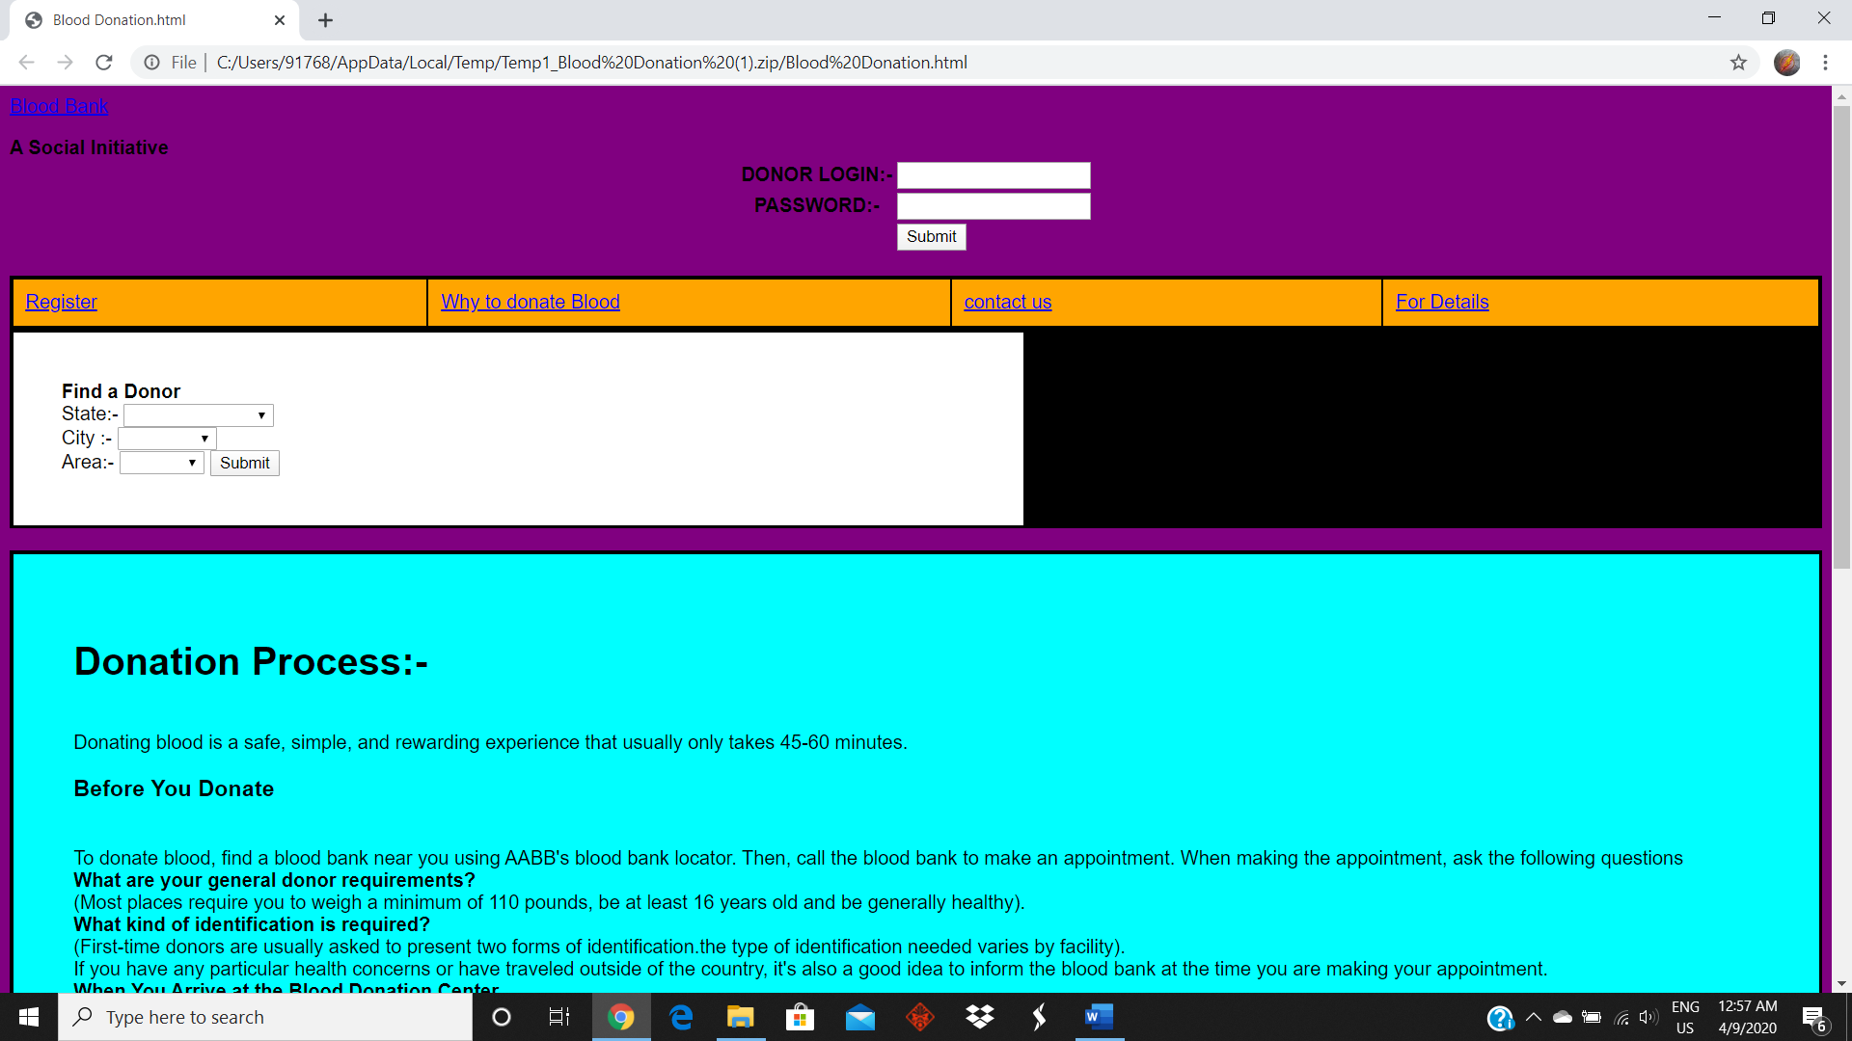

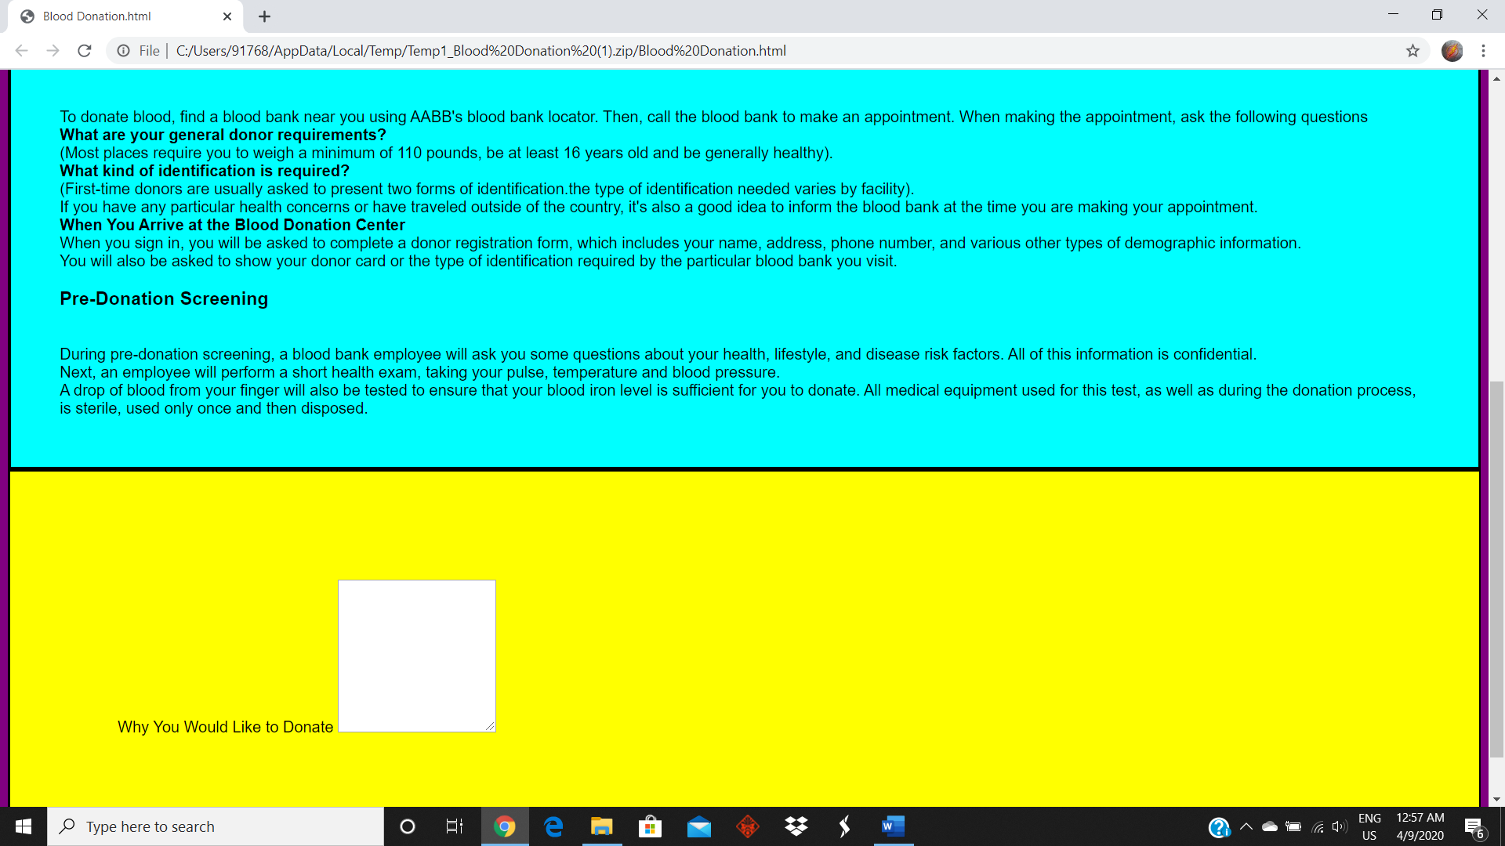

CONCLUSION-

A Blood Bank is a software product suite designed to improve the quality and management of blood bank and hospital health care management in the areas of health process analysis and activity-based costing. Blood Bank Manager enables you to develop your organization and improve its effectiveness and quality of work .Managing the key processes efficiently is critical to the success ofthe pharmacy. Blood Bank Manager helps you manage your processes. A Blood Bank Manager provides all process management tool elements: modeling, analysis ,and simulation. Documentation though an important part of a blood bank management, is a nonproductive exercise for the intellectual human being ,whose ability lies in core areas of excellence. Hence a systematic approach to the way documents are managed , can transform your pharmacy retailing resources to its highest utility and advantage.

LINK FOR THE EXPLANATION OF PROJECT-

https://www.youtube.com/watch?v=o6_JIj_Q_ns&feature=youtu.be